Poetry in prison

Topic: Reading and talking about poetry
Level: Entry 3 (National 4) to Level 2
Time: minimum 110 minutes

Aims
- To develop learners’ ability to read different texts such as poems.
- To give practice of extracting information from a text.
- To develop learners’ vocabulary of prison life.
- To improve learners’ stress and intonation.

Objectives
All learners will be able to:
- predict what poems could be about
- read and understand at least one poem
- discuss what the poem means
- write some sentences using colloquial English.

Level 1 and 2 learners will be able to:
- read and understand at least 2 poems
- write a simple poem.

Introduction
This lesson is about poetry in prison. It provides students with three authentic poems first published in Inside Time – the National Newspaper for Prisoners.

The lesson is aimed at high level learners. If your learners are lower level for example, Entry 3 / National 4, it might be better to use just 1 of the poems and accompanying activities.

Tip! The poems are about experiences of being in prison. Some learners might find them upsetting or not want to discuss the topic. In this case, choose alternative poems that you think your learners will enjoy and create similar activities to the ones here.

Preparation
You will need:
Resource 1: images related to the poems
Resource 2: poem 1 – one copy for each learner
Resource 3: one copy for each learner
Resource 4: poem 2 – one copy for each of the learners in group A (half the class)
Resource 5: one copy for each of the learners in group A (half the learners)
Resource 6: poem 3 – one copy for each of the learners in group B (half the class)
Resource 7: one copy for each of the learners in group B (half the learners)

Procedure
Warmer – An introduction to poetry (10 minutes)
- Show a very simple poem such as ‘Roses are red’. Read it aloud and then get learners to read along with you, and then on their own.

Roses are red,
Violets are blue,
Sugar is sweet,
And so are you.

Tip! You may need to sketch or show a picture of a rose and a violet to help all learners understand.
Emphasise the stress and intonation in the poem and drill this with the learners. You could get the learners to clap the stressed words with you.

- Elicit what type of text it is; for example ask ‘Is it a letter, a text message or a poem?’
- Ask why this text is poetry rather than prose. You could focus on the use of rhyme, etc.

Activity 1 – Speaking about poetry in your first language (10 minutes)
- Conduct a short discussion on poetry in learners’ first languages. You could write these questions on the board and ask them to discuss in pairs or small groups.
Do you read poetry in your first language?
Do you have a favourite poem or poet?
Do you remember poems from when you were a child?

- Ask for some feedback from the learners.
- Encourage learners to contribute a poem, rhyme or song in their own language.
- Tell learners that they are now going to read some poems written by real people in prison.

Tip! Be prepared for some learners not to have any thoughts about poetry. Instead you could ask them about popular songs in their language or nursery rhymes from their childhood.

Activity 2 – Prediction about the poem (10 minutes)
- Show the pictures from resource 1 on the screen and ask learners to describe to their partner what they can see in the pictures.
- Elicit who the poems(s) were written by (prisoners).
- Ask the learners to speak to their partner about what think the poem(s) will be about.

Activity 3 – Killing Time (20 minutes)
- Write kill time and do time on the board. Ask learners if they know what the phrases mean. Elicit ideas from the learners before explaining the phrases.

To kill time: to do something that keeps you busy while you are waiting for something else to happen
To do time: to spend a period of time in prison

- Display and hand out resource 2 – the poem Killing Time.
- Read the poem aloud with appropriate feeling and ask learners to follow along.
- Put the learners in pairs to read and discuss the poem. Set some questions about the poem to make sure learners understand the gist of it. For example:

Who wrote the poem?
Where is he?
Does he sound happy about his situation?

- You could also ask for any comments about language features in the poem, such as rhyme. Pick out a couple of words that rhyme. Can learners identify other words that rhyme? Give learners more time in pairs to look through the poem.
- Hand out resource 3 – questions about the poem “Killing Time”.
- Model task 1 as a group and then leave learners to work through the next activities in pairs.
- Review the answers by asking a range of learners. Encourage as much discussion about the poem as possible.

Differentiation/ extension
Ask early finishers to practise reading the poem in pairs.

Tip! You may need to practise reading all of the poems a few times so that you can emphasise the stress and intonation and the musicality of poetry. This will help you to model the stress and intonation patterns for the learners to copy.

Activity 4 – Reading poems (20 minutes)
- There are two more poems for learners to read. Split the class in two groups (A and B) and give resource 4: Overcome It All to group A and resource 6: Wrong Place, Wrong Time to group B. it would be best to give these one between 2 to ensure they work with a partner.
- Before giving learners a resource to go with their poem, give them plenty of time to read the poem alone or in pairs. Tell learners to underline words or phrases they cannot understand and to ask you for help.
- Monitor and support learners. Help them to get the gist of the poem they have been given.
- After you feel learners have had time to read and discuss their poem, give resource 5 to each learner in group A and resource 7 to each learner in group B.
- Ask them to compare their answers in pairs or small groups after they have done the activities.

Differentiation/ extension
If learners finish their resource, let them try reading the other text and the activities that go with it. You may also use this as an extension task and ask group A learners to explain their text to the group B learners. See further instructions below.

Activity 5 – Discussion (15 minutes)
- Make sure that all learners have a copy of both poems - Overcome It All to and Wrong Place, Wrong Time.
- Review both of the poems. First read the poem and ask the learners to follow along. Then review some of the questions from the resource. Repeat for the next poem.
- Invite comments on what learners think about the poems. For example, do they like them? Which is their favourite of the three poems?

Differentiation/ extension
Depending on the abilities of the learners, you could ask group A to present Overcome It All to the class (read the poem then answer the questions, for group B to listen and respond). Group B could then present Wrong Place, Wrong Time.

Activity 6 – Creating our own poetry (20 minutes)
    - Focus on Overcome It All and the phrases ‘wanna’, ‘don’t wanna’ and ‘gonna’. Write these on the board which space to add ideas later.
    - Ask learners to write some things they personally ‘wanna’, ‘don’t wanna’ and are ‘gonna’ do. They could discuss this in pairs.
    - Elicit their thoughts and write them on the board.
    - Aim to create a group poem with learners’ ideas; support them with vocabulary and with rhythm or rhyme.

Tip! Since this task could be challenging for some learners, you may wish to give them a theme, such as food or what they want to do in their ESOL classes.

Cooler (5 minutes)
- Invite all learners to share a word they learnt from the poems they read. Write these on the board.
- Alternatively, ask learners what they think about the prison poetry they have read today. Do they think that writing poetry in prison is a good idea?

Extension activities / Homework
- Learners could translate a poem from their first language into English. These poems could then be brought to class to work on in a follow-up lesson.
- As an extension for Activity 2, ask learners to explain their text to another group. For example, learners in group A who read Overcome It All could talk about the poem to group B learners. Group B learners could then explain Wrong Place, Wrong Time to group A learners.
- There are many more poems in Inside Time – the National Newspaper for Prisoners, in print or online at http://www.insidetime.co.uk/poems.asp. Select other poems that you think the learners would be interested to read. You can access them at or from paper copies of Inside Time.
- Ask learners to search Inside Time for more poems to read or choose poems they like.
- Arrange a trip to the library and ask learners to choose a poetry book and 1 poem from that book.
- Give learners a list of words to practise spelling for their next lesson.
- Set learners the task of writing their own poem. They may want to do this in their first language or in English.

Answer key
Resource 3
Task 1
1 – e 2 – f 3 – b 4 – a 5 – c 6 – d

Task 2
- He soldiers on; he doesn’t count the days he’s been in prison.
- Prisons in the England Wales are part of Her Majesty’s Government. They are called HMP, meaning Her Majesty’s Prison. Her Majesty is another name for the Queen.
- No, he doesn’t like the food. He calls it ‘substandard’ or below standard.
- Yes, he has a release date.
- He misses his family.

Resource 5
Task 1
1 – b 2 – d 3 – e 4 – f
5 – h 6 – c 7 – g 8 – a

Task 2
- wanna = want to, gonna = going to
- He wants to live a normal life, settle down and maybe get married. He doesn’t want to have to go to prison again and make new friends there. He doesn’t want to disappoint his family again.
- He’s going to help his brother and his sisters.
- He has been studying in prison and has got his GCSEs or qualifications.
- Staying calm and keeping cool will help him to finish his sentence.

Resource 7
Task 1
Use dictionary definitions but here are some ideas:
guilty – feeling unhappy because you have done something bad
innocent – when someone did not commit a crime (the opposite of guilty)
justice – treating people fairly; the justice system is the legal system used to treat people in a fair way
mercy – when someone with power forgives someone they have the right to punish
punishment – suffering for what you have done wrong
weapon – an object such as a knife or gun used to hurt or kills someone

Task 2
- He said he was innocent.
- Murder
- 25 years
- The police/the authorities

Resource 1

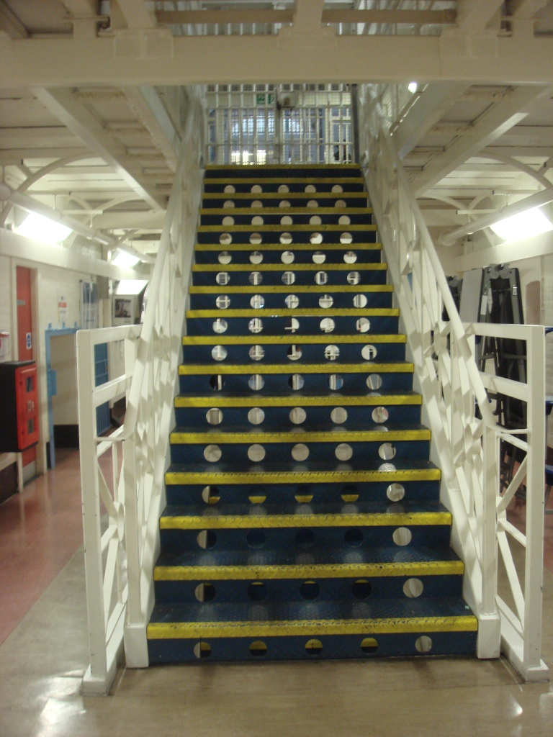

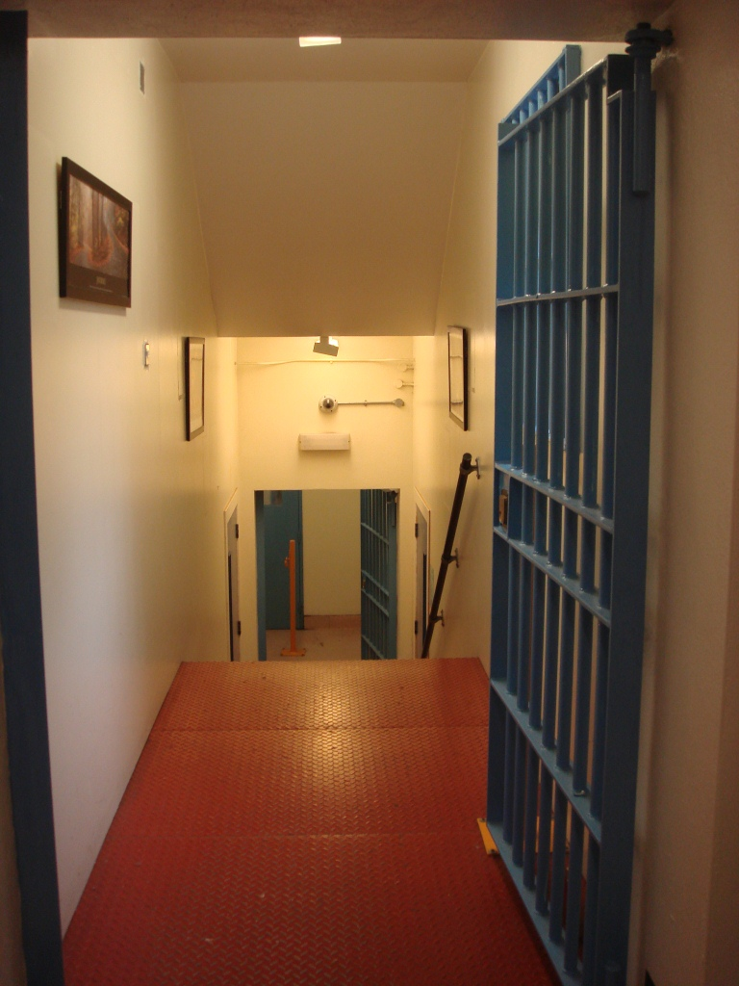

Resource 2: Poem 1 - Killing Time

1 We’re all just killing time
2 Everyone’s got things to get back to
3 Can’t wait to get back to mine
4 In this prison of brick and steel
5 We just soldier on, no matter what we feel
6 We don’t count how many days it’s been
7 Since we’ve been guests of the Queen
8 Substandard food, thinking what have I just ate
9 At least I’ve got my release date
10 We work out
11 We zone out
12 Got a visit, get the gel and the comb out
13 I miss the wife and the kid
14 But I’ve got to answer for the wickedness I did
15 But we’re just killing time
16 So you do yours and I’ll do mine

*This poem was first published in Inside Time – the National Newspaper for Prisoners. It was written by Wesley Bradbery, HMP The Mount

Resource 3 – Killing Time

Task 1 – Vocabulary
Match the phrases with the definition

- to kill time (line 1) a) to daydream
- to soldier on (line 5) b) to do exercise
- to work out (line 10) c) to do your hair
- to zone out (line 11) d) to spend time in prison
- to get the gel/comb out (line 12) e) to do something while waiting
- to do time (line 15 and 16) f) to continue doing something difficult

Task 2 – Read and understand
Read the poem and answer the questions

- How does he cope with life in prison? (line 5 and 6)
…………………………………………………………………………………………………..
- How is he a guest of the Queen? (line 7)
…………………………………………………………………………………………………..
- Does he like the food in prison? (line 8)
…………………………………………………………………………………………………..
- Does he know when he’s leaving prison? (line 9)
…………………………………………………………………………………………………..
- What does he say about his family? (line 13)
…………………………………………………………………………………………………..

Task 3 – What do you think?
Ask people in your class, how do you kill time in prison?

Resource 4: Poem 2 – Overcome It All

1 I was always in and out of block
2 No television just the sound of my clock
3 Going mad just staring at the wall
4 But I never thought I’d overcome it all
5 I’m never coming to jail again
6 I don’t wanna make new friends
7 I just wanna live a normal life
8 And settle down, maybe find a wife
9 I don’t wanna let my family down
10 I don’t wanna keep moving around
11 I just wanna stay in one place
12 And not disappear without a trace
13 So I’m gonna help my sisters out
14 By making sure I’m always about
15 I’m gonna get my brother out of crime
16 And save him before he gets some time
17 I never thought I’d overcome it all
18 Doing education feels mad, like school
19 Got my GCSE’s, it’s great
20 I’m finished, now I’ll help my mate
21 Two years left, the end is near
22 But secretly outside’s most I fear
23 But if I stay calm in jail and keep my cool
24 I know for a fact I’ll overcome it all
25 But it’s time for the poem to end
26 If you need to talk I will be a friend
27 I know it’s my time to change
28 You know what, I’m out the game!

*This poem was first published in Inside Time – the National Newspaper for Prisoners. It was written by Jordan Duff, HMP Aylesbury.
Resource 5 – Overcome it all
Task 1 – Rhyming words
Read the poem and match the words that rhyme (sound similar).
- block a) all
- crime b) clock
- end c) fear
- great d) time
- life e) friend
- near f) mate
- place g) trace
- wall h) wife

Task 2 – Read and understand
Read the poem and answer the questions.
- What does “wanna” mean? (line 6 - 12) What does “gonna” mean? (line 13 - 16)
…………………………………………………………………………………………………..

- What does he want to do? What does he not want to do?
…………………………………………………………………………………………………..

- What is he going to do?
…………………………………………………………………………………………………..

- What positive things is he doing?
…………………………………………………………………………………………………..

- What will help him to overcome life in prison?
…………………………………………………………………………………………………..

Task 3 – Your life

Think about your life. Ask someone these questions: What do you want to do next? What do you not want to do? What helps you cope with life in prison?

Resource 6: Poem 3 – Wrong Place, Wrong Time
1 I told them I didn’t kill anyone, they told me I had the wrong friend
2 I told them I don’t deserve this, they told me my life deserves to end
3 I told them I was innocent, they told me murder was my crime
4 I told them this isn’t joint enterprise, it’s wrong place, wrong time
5 I told them I have a son, they told me I was bad
6 I told them I tried to stop the fight, they told me I was mad
7 I told them I’m not guilty, they told me this punishment is mine
8 I told them this isn’t joint enterprise, it’s wrong place, wrong time
9 I told them show me mercy, they told me 25 years I.P.P
10 I told them I’m only 20, they told me you’ll be 45 before you’re free
11 I told them this isn’t justice; they told me our laws are fine
12 I told them this isn’t joint enterprise, it’s wrong place, wrong time
13 I told them I didn’t have a weapon, they told me they didn’t care
14 I told them I wasn’t a part of it, they told me you’re guilty you were there
15 I told them I was innocent, they told me murder was my crime
16 I told them this isn’t joint enterprise, it’s wrong place, wrong time

*This poem was first published in Inside Time – the National Newspaper for Prisoners. It was written by Alex Carr, HMP Wandsworth.

IPP (Indeterminate sentence for Public Protection) = a type of prison sentence for serious and violent offenders who must serve a minimum jail term and then find out their release date from the Parole Board.

Resource 7 – Wrong Place, Wrong Time

Task 1 – Vocabulary

What do these words mean? Check in a dictionary.

guilty
innocent
justice
mercy
punishment
weapon

Task 2 – Read and understand

Read the poem and answer these questions.

- Did he tell them he was guilty or innocent?
…………………………………………………………………………………………………..

- What was his crime?
…………………………………………………………………………………………………..

- How long is his prison sentence?
…………………………………………………………………………………………………..

- He says, “I told them…” Who are “them”?
…………………………………………………………………………………………………..

Task 3 - What do you think?

Discuss the questions with a partner.

- Do you think he is guilty or innocent? Why?
- Do you think he was in the wrong place at the wrong time?
- Have you ever been in the wrong place at the wrong time?

Definitions from Cambridge Advanced Learners Dictionary & Thesaurus Cambridge University Press

